CO2- ACTIVITY 2 PYTHON MySQL

Name: Sahasra V
Reg no: 192424234
Course: DSA0504 Query Processing for Data Science

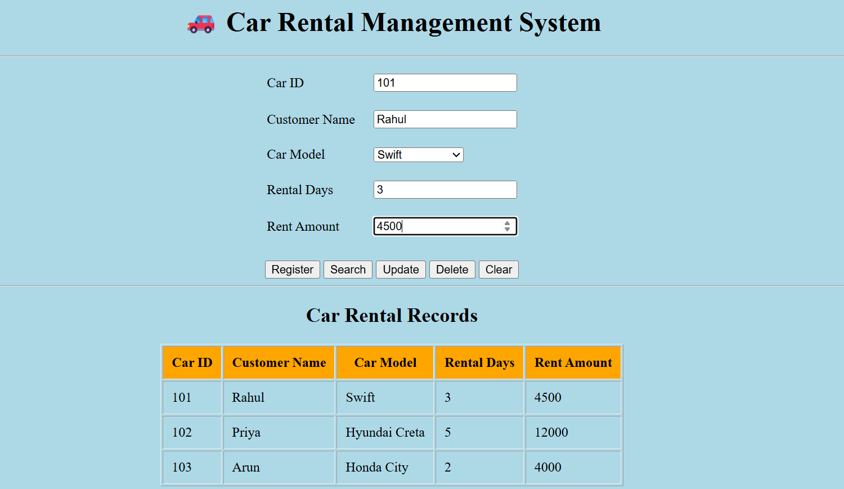

Car Rental Management System
The Car Rental Management System is a simple web-based application developed using HTML for the user interface and MySQL for database management. The system provides an easy way to manage car rental information by allowing users to enter customer and vehicle details through a user-friendly form.
The frontend is designed using HTML, which displays the registration form, buttons, and rental records in a structured format. The backend database is managed using MySQL, where all rental information is stored and maintained using SQL queries.
The system supports basic database operations such as:
- Registering a new car rental record
- Searching rental details
- Updating existing rental information
- Deleting rental records
These operations are performed using MySQL queries such as INSERT, SELECT, UPDATE, and DELETE, making it a simple CRUD (Create, Read, Update, Delete) application.

Technologies Used
- Frontend: HTML
- Database: MySQL
- SQL Operations: CREATE, INSERT, SELECT, UPDATE, DELETE

